Supplementary:
9.1 – Eligibility criteria (supplements)
Other Eligibility Criteria
Study type: Studies that include original empirical data will be included. Theoretical papers will be excluded from the study but may be discussed at a separate section of the paper.
Duplicated data (data that have been reported in other papers) will be excluded. This will be done manually by checking the description of data used for the research, references, and citations of papers.
We will exclude papers that have no full text that we can access (but we may try to contact the authors), studies that are in languages other than English and papers published before 2010.
Reasons for exclusion of articles will be listed by the end of the screening to provide infographics on why these articles are not included in the systematic map.

Terminology.
- Ocean warming: Ocean warming refers to increase of temperature in oceanic waters by the means of raising SSTs and thereafter the increase in temperature of sea water in various depths.
- Ocean Acidification (OA) and warming interaction: Drop in ocean’s pH value due to accumulation of carbon dioxide gases in atmosphere (Kleypas et al., 1999; Feely et al., 2004; Orr et al., 2005). Some 30% of the atmospheric CO2 were absorbed by the ocean (Feely et al., 2004; Sabine et al., 2004) and it led to chemical reactions which reduced the amount of carbonate ions available in the water. This makes it difficult for marine calcifying organisms to form their biogenic calcium carbonate skeletons (Guinotte et al., 2006). Ecological changes due to ocean warming combined with ocean acidification could compound and led to further damage to the calcifying organisms in the ocean.
- Biological responses: Intrinsic response of an individual species or organism due to change of their environment.
- CEESAT: Acronym for Collaboration of Environmental Evidence Synthesis Assessment Tool. (Guidelines and Standards for Evidence Synthesis in Environmental Management, 2022)
- Coral: Members of the Anthozoa orders; Scleractinia, Corallimorpharia, Alcyonacea and Antipatharia which include the true stony corals, soft corals, black corals, etc.
- Coral bleaching: Coral bleaching occurs when the water that the coral system lives in becomes warmer than the temperature threshold of the coral, causing coral to expel the symbiont zooxanthellae, leaving a white coral skeleton. Corals at this stage are likely still alive.
- Coral populations: Mixed and single species populations of coral within an ecosystem.
- Coral reef ecosystem: coral dominated ecosystem.
- Coral reef refugia: Coral reef refugia are areas where the physical, biological, and ecological characteristics allow for a potential habitat for corals in the rising tide of climate change (Keppel et al., 2011; Carter et al., 2020)
- Degree Heating Weeks: Degree heating weeks (DHWs) is a measure of accumulated thermal stress experienced by corals. It is calculated by adding up days where temperatures exceed the usual summertime maximum by at least 1 degree Celsius over a 12-week period (Liu et al., 2013).
- Ecological responses: Response of an individual species or a group to the change in environment.
- High latitude reef: Reefs that are in regions above and below 28°N and 28°S respectively (Ross et al., 2018). As referred in Beger et al. (2013) work and the henceforth figure and table. (Figure 1. And Table. 1, see appendix)
- Marine Heat Wave: Marine heat wave (MHW) is calculated from SST data obtained by satellite, in-situ instruments, or other means of observed data collection. It is defined as thermal events where SST exceeds the 90th percentile of the climatological dataset for at least 5 consecutive days (Hobday et al., 2016).
- Marginal reef: Marginal reefs are where the environmental conditions are marginal or close to threshold for the survival of the coral species, meaning that the living conditions are less than ideal but still feasible for coral species to survive.
- PECO: (P)opulation, (E)xposure, (C)omparator and (O)bjective. It is a metric used to define a problem statement in environmental studies, originally used in medicinal studies.
- Primary literature: These are literatures where original results from the authors were reported in the form of a report of their findings.
- Secondary literature: These are literatures that the authors integrate information of primary literature into a separate document, such as a review.
- Subtropical: The region surrounding the tropical regions. However, in this work the subtropical ecoregions are defined as in Figure 1 and Table 1 (See appendix).
- Systematic map: Methodical overviews of the quantity and quality of evidence in relation to an open question of policy or management relevance. (Guidelines and Standards for Evidence Synthesis in Environmental Management, 2022)
- Temperate: The region surrounding the subtropical regions. However, in this work the temperate ecoregions are defined as in Figure 1 and Table 1.
- Thermal limit: The threshold in degree Celsius when the temperature reaches above 4 degrees when using degree heating weeks (DHW) or when the temperature is above the 90th percentile of the temperature recorded when using marine heatwaves (MHW) as the measuring metric.
- Tropicalisation: Tropicalisation refers to a region outside the tropical latitudes increasing in number of warm-affinity species and decreasing in number of cool-water species (Verges et al., 2019).

Data Extraction Variables.
Link to Google Form:
https://docs.google.com/forms/d/e/1FAIpQLSfMpoavyo0kdICxCtlZp_TJscFPdSQbOtfJdJDMENqZcIhbaA/viewform
- Title of Article (Short answer text)
- First Author, Last Author (Last name only, e.g. Doe, Doe) (Short answer text)
- Corresponding or First Author Location (Institution and country, e.g. University of New South Wales, Australia) (Long answer text)
- Year of Publication (YYYY) (Short answer text)
- DOI (10.XXXX/xxxxxx) (Short answer text)
- Reason for exclusion (Checkboxes)
- Comments on Exclusion (If article is excluded, no further questions are needed to be answered. (Short answer text)
- Is the article included for screening? (Yes/No)
- Study type (Checkboxes)
- Comment on study type (Short answer text)
- Keywords used in this literature (Checkboxes)
- Location of Study (Location Name only)
You can download the .html map with pop up at the following link:
Ecoregion Popup File (Short answer text)
- Coastal/Offshore/Island? (Checkboxes)
- Is it in proximity to a exclusive economic zone that is a tourist attraction or urbanisation region? (Yes/No)
- If yes, please specify the area: (Short answer text)
- What is the proximity of the site in relation to the mentioned area? (United Nations Conference on the Law of the Sea, 1982). Select multiple if applicable. (Checkboxes)
- Approximate Latitude, Longitude, minimum 2 decimal places (e.g. 22.3193N, 114.1694E) (Short answer text)
- Development Status of Country (Use UN definition: https://www.un.org/en/development/desa/policy/wesp/wesp_current/2014wesp_country_classification.pdf ) (Multiple choices)
- Did the study take place at a protected area (E.g. marine park, etc.)? (Yes/No)
- If the study took place at a protected area, please specify: (Short answer text)
- Did the author refer to the event taking place in an ocean current or other water bodies? (Checkboxes)
- When did the event start? (e.g. Sep 2022) (Short answer text)
- When did the event end? (e.g. Feb 2023) (Short answer text)
- When did the study start? (e.g. Sep 2022) (Short answer text)
- When did the study end? (e.g. Feb 2023) (Short answer text)
- Did the study take place at the same time as the event? (Yes/No)
- Temperature data categorisation (Checkboxes)
- If in-situ, from what depth was the data taken? N/A if satellite-derived or did not specify in paper. (Unit in metres, e.g. 10) (Short answer text)
- If in-situ, which data source is it from? (E.g. IMOS, etc.)? N/A if not specified in paper. (Short answer text)
- What organisms are studied? (Checkboxes)
- What species are studied? If more than one species, please separate each specie name by coma (,) (Short answer text)
- What are other environmental variables recorded? (e.g. Chlorophyll a concentration, etc.) (Short answer text)
- Is there an outcome/prediction provided in the study? (Checkboxes)
- If an outcome is provided, please provide a short description of the outcome (Short answer text)
- If a prediction is provided, please provide a short description of the prediction (Long answer text)
- Is the studied site classified as phase shifted/tropicalised/refugia/degraded, etc.? (Checkboxes)
- Is there a causality in the study? (Yes/No)
- Stressor used (Checkboxes)
- Severity of event based on DHWs/MHWs definition (Short answer text)
- Main Finding of this publication (Long answer text)
- Remark (Long answer text)
Appendix
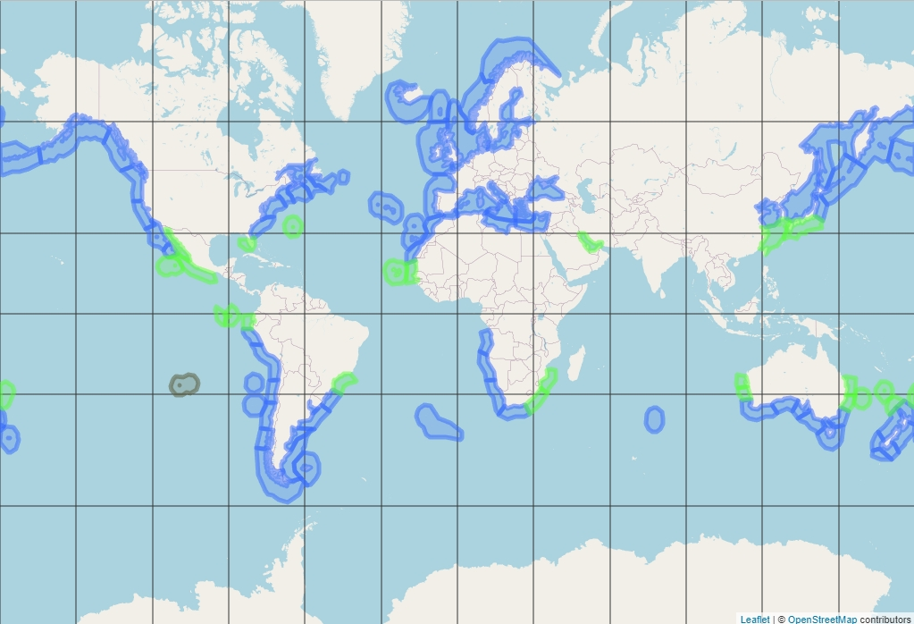
Figure 1. Subtropical (in green) and temperate (in blue) ecoregion of the world (Beger et al., 2013; Spalding et al., 2007). Grey ecoregion includes both tropical and subtropical ecoregions.

Table 1. Subtropical and temperate ecoregions (Beger et al., 2013; Spalding et al., 2007)
Ecoregion | Country | Location Name | Longitude | Latitude
Northern European Seas | Iceland | South and West Iceland | -22.19 | 64.40
 |  | Faroe Plateau | -7.00 | 62.18
 | Norway | Southern Norway | 5.77 | 64.00
 | Norway | Northern Norway and Finnmark | 12.19 | 68.69
 | Various, Europe and Russia | Baltic Sea | 20.00 | 57.61
 | Various, Europe | North Sea | 3.39 | 56.29
 | Various, Europe | Celtic Sea | -10.85 | 51.36
Black Sea | Various, Eurasia | Black Sea | 33.81 | 43.31
Cold Temperate Northwest Pacific | Various, Asia | Sea of Okhotsk | 149.69 | 58.03
 | Russia | Kamchatka Shelf and Coast | 169.82 | 58.08
 | Japan | Oyashio Current | 153.74 | 46.44
 | Japan | Northeastern Honshu | 143.37 | 40.45
 | Various, Asia | Sea of Japan | 135.02 | 39.91
 | Various, Asia | Yellow Sea | 123.42 | 35.03
Cold Temperate Northeast Pacific | USA | Aleutian Islands | -173.41 | 54.04
 | USA | Gulf of Alaska | -147.74 | 59.02
 | Canada | North American Pacific Fijordland | -133.46 | 54.88
 | Various, North America | Puget Trough/Georgia Basin | -123.44 | 49.14
 | Various, North America | Oregon, Washington, Vancouver Coast and Shelf | -125.66 | 47.19
 | USA | Northern California | -122.51 | 35.83
Warm Temperate Northeast Pacific | Mexico | Southern California Bight | -119.35 | 31.40
 | Mexico | Magdalena Transition | -114.17 | 24.83
Gulf of Guinea | Angola | Angolan | 11.29 | -10.35
Warm Temperate Southeastern Pacific | Peru | Central Peru | -79.28 | -10.84
 | Various, South America | Humboldtian | -72.70 | -20.16
 | Chile | Central Chile | -72.85 | -29.73
 | Chile | Araucanian | -75.88 | -40.29
Juan Fernandez and Desventuradas | Chile | Juan Fernandez and Desventuradas | -79.43 | -30.29
Warm Temperate Southwestern Atlantic | Various, South America | Rio Grande | -47.83 | -32.61
 | Various, South America | Rio de la Plata | -56.64 | -35.31
 | Various, South America | Uruguay-Buenos Aires Shelf | -54.46 | -37.68
Magellanic | Argentina | North Patagonian Gulfs | -64.06 | -44.56
 | Argentina | Patagonian Shelf | -65.80 | -50.41
 | Falkland Islands | Malvinas/Falklands | -59.51 | -51.84
 | Chile | Channels and Fjords of Southern Chile | -75.34 | -53.52
 | Chile | Chiloense | -77.12 | -43.56
Tristen Gough | St. Helena | Tristan Gough | -11.71 | -38.00
Benguela | Namibia | Namib | 10.84 | -21.07
 | Various, Africa | Namaqua | 14.61 | -30.69
Agulhas | South Africa | Agulhas Bank | 23.12 | -35.42
Amsterdam – St Paul | France | Amsterdam – St Paul | 77.54 | -38.27
Northern New Zealand | New Zealand | Northeastern New Zealand | 177.81 | -36.59
Southern New Zealand | New Zealand | Chatham Island | -176.48 | -43.89
 | New Zealand | Central New Zealand | 170.67 | -43.83
 | New Zealand | South New Zealand | 166.97 | -46.62
 | New Zealand | Snares Island | 166.56 | -48.03
Southern Australian Shelf | Australia | Cape Howe | 149.96 | -37.43
 | Australia | Bassian | 146.69 | -43.79
 | Australia | Western Bassian | 141.48 | -39.91
Southwest Australian Shelf | Australia | South Australian Gulfs | 135.70 | -36.77
 | Australia | Great Australian Bight | 128.97 | -33.70
 | Australia | Leeuwin | 115.45 | -34.79
Warm Temperate Northwest Pacific | Japan | Central Kuroshio Current | 136.50 | 33.07
 | Various, Asia | East China Sea | 126.10 | 29.96
Warm Temperate Northeast Pacific | Mexico | Cortezian | -111.22 | 27.33
Tropical Northwestern Atlantic | Bermuda | Bermuda | -64.81 | 32.29
 | USA | Floridian | -83.40 | 27.34
West African Transition | Republic of Cabo Verde | Cape Verde | -23.98 | 16.22
 | Various, Africa | Sahelian Upwelling | -18.74 | 17.85
Somali/Arabian | Middle East | Arabian (Persian) Gulf | 51.98 | 26.64
Western Indian Ocean | Mozambique | Delagoa | 36.41 | -25.66
Lord Howe and Norfolk Islands | Australia | Lord Howe and Norfolk Islands | 163.44 | -30.17
Easter Island | Chile | Easter Island | -109.50 | -27.14
Tropical East Pacific | Mexico | Revillagigedos | -112.71 | 19.03
 | Mexico | Mexican Tropical Pacific | -101.60 | 15.78
 | Various, South America | Guayaquil | -82.51 | -1.52
Galapagos | Ecuador | Eastern Galapagos Islands | -89.63 | -1.01
 | Ecuador | Western Galapegos Islands | -91.57 | -1.02
Warm Temperate Southwestern Atlantic | Brazil | Southeastern Brazil | -43.58 | -24.85
Agulhas | South Africa | Natal | 29.19 | -33.02
Northern New Zealand | New Zealand | Kermadec Island | -178.12 | -29.62
 | New Zealand | Three Kings – North Cape | 172.58 | -34.29
East Central Australian Shelf | Australia | Tweed – Moreton | 154.85 | -27.95
 | Australia | Manning – Hawkesbury | 153.73 | -31.95
West Central Australian Shelf | Australia | Shark Bay | 113.41 | -25.86
 | Australia | Houtman | 113.95 | -28.57

