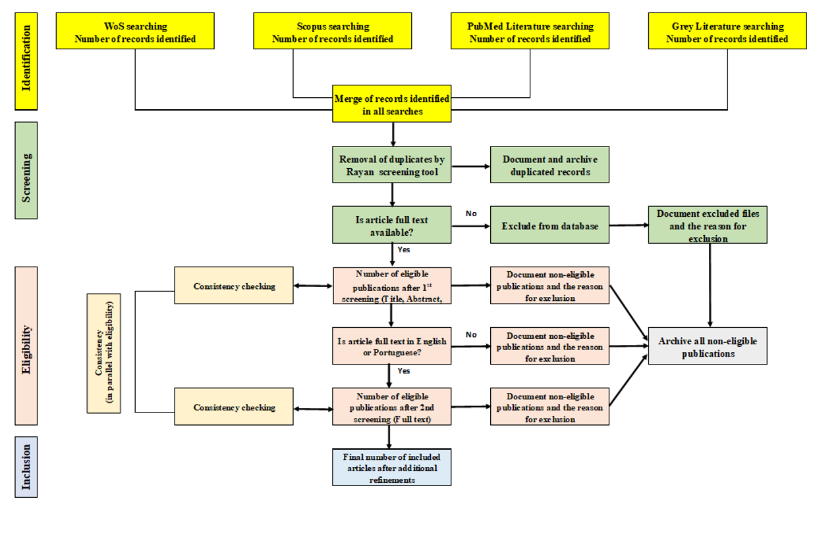
Figure 1. Summary of map protocol screening and eligibility strategy and consistency checking

