Per- and Polyfluoroalkyl Substances (PFAS) Biomagnification in Food Webs: A protocol for a systematic review and meta-analysis

SUPPLEMENTARY FIGURES

Supplementary Figure 1
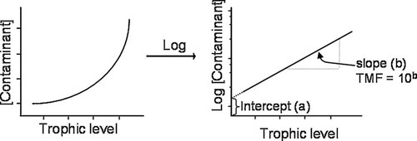
Supplementary Figure 1. Trophic magnification factors (TMFs) are the change in contaminant concentrations per trophic level. For contaminants that increase exponentially in the food web, a log-normal relationship results in a regression slope (b), from which the TMF is calculated by the antilog (10^{b} or e^{b}). The regression slope is called trophic magnification slope (TMS). The intercept of the regression is represented by (a) and may indicate inputs of the contaminant to the base of the food web. Figure from Borgå et al. (2012).
Note: This meta-analysis will use the trophic magnification slope (TMS) as effect size. If a study does not report the slope but reports the TMF, we will measure the slope log transforming the TMF.

Supplementary Figure 2
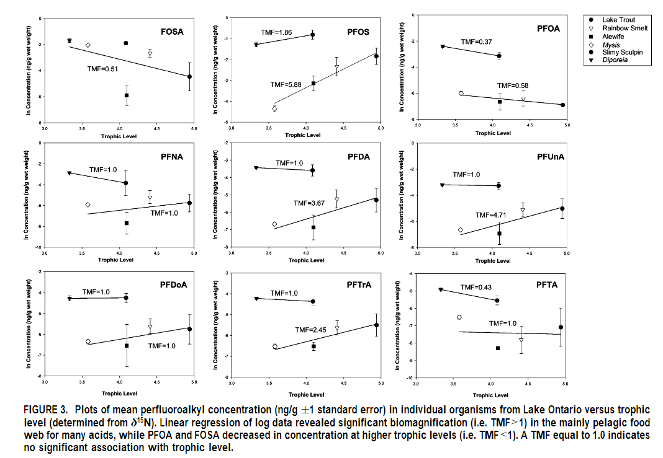
Supplementary Figure 2. This is an example of an eligible study reporting sufficient data for effect size calculation. The study provides linear regression plots of log PFAS concentrations versus trophic levels. We will extract means and standard errors of data points from these plots to calculate the trophic magnification slope (TMS) and its standard error. This figure is from Martin et al. (2004).

Supplementary Figure 3
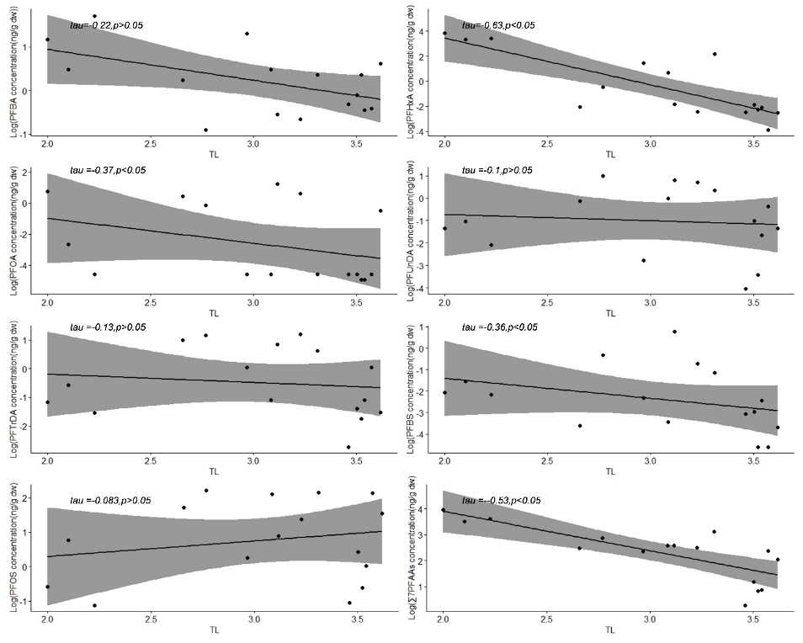
Supplementary Figure 3. This is an example of an eligible study reporting sufficient data for effect size calculation. The study provides linear regression plots of log PFAS concentrations versus trophic levels. We will extract data points from these plots to calculate the trophic magnification slope (TMS) and its standard error. This figure is from Du et al. (2021).

Supplementary Figure 4
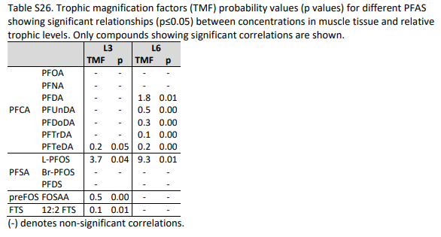
Supplementary Figure 4. This is an example of a study with a high risk of reporting bias. The study selectively reported the TMF outcome, removing results that were not statistically significant. This figure is from Langberg et al. (2020).

REFERENCES
Borgå, K., Kidd, K. A., Muir, D. C., Berglund, O., Conder, J. M., Gobas, F. A., ... & Powell, D. E. (2012). Trophic magnification factors: considerations of ecology, ecosystems, and study design. Integrated environmental assessment and management, 8(1), 64-84.
Du, D., Lu, Y., Zhou, Y., Li, Q., Zhang, M., Han, G., ... & Jeppesen, E. (2021). Bioaccumulation, trophic transfer and biomagnification of perfluoroalkyl acids (PFAAs) in the marine food web of the South China Sea. Journal of hazardous materials, 405, 124681.
Langberg, H. A., Breedveld, G. D., Slinde, G. A., Grønning, H. M., Høisæter, Å., Jartun, M., ... & Hale, S. E. (2020). Fluorinated precursor compounds in sediments as a source of perfluorinated alkyl acids (PFAA) to biota. Environmental Science & Technology, 54(20), 13077-13089.
Martin, J. W., Whittle, D. M., Muir, D. C., & Mabury, S. A. (2004). Perfluoroalkyl contaminants in a food web from Lake Ontario. Environmental science & technology, 38(20), 5379-5385.

